Math 240 Exam 3 Fall 2011

Show all of your work in the exam booklet provided to you. Full credit will not be awarded for correct answers unless sufficient supporting work is presented. If you use a calculator on a problem be sure to write down what you entered into the calculator, what you did, and what resulted to explain your answer.

1. (12 pts) A is a 11 x 8 matrix with rank 6. Give the dimension of these subspaces.
a) Col(A) b) Col(A^{T}) c)Row(A) d)Row(A^{T}) e)Nul(A) f) Nul(A^{T})

2. (6 pts) Let A be a 11 x 8 matrix with rank 6 and let T be the linear transformation defined by T(x) = Ax. Determine if each of the following statements is true or false.

a) If Ax = b has a solution then that solution is unique.
b) Ax = b has a solution for every choice of b in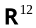.
c) T is a one-to-one function.

3. (12pts) Let A = 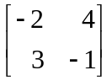.
a) What is the characteristic equation for A?
b) What are the eigenvalues for A? Show your work.

4. (16 pts) Let A = 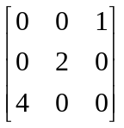. The eigenvalues of A are 2 and -2.
Is A diagonalizable? If so find a matrix P such that P⁻¹AP = D.

5. (10 pts) Let A be an n x n matrix with eigenvalue λ and let ES = 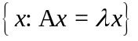. Prove that ES is a subspace of 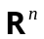.

6. (10 pts) Let A and B be n x n matrices. If A is similar to B and B is diagonalizable, prove that A is diagonalizable.

7.(12 pts) This directed graph shows the probability that a smoker will become a nonsmoker or will continue to smoke a year later and the probability that a nonsmoker will begin to smoke or will continue not to smoke a year later.
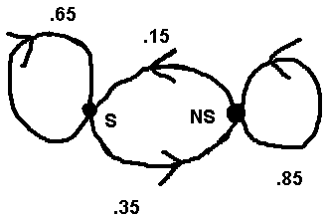
a) What is the stochastic matrix for this situation?
b) If nonsmokers make up 60% of a certain population in the year 2011, what percentage will this model predict to be nonsmokers in 2012?

8.( 12 pts) The first three Laguerre polynomials are 1, 1- t, and 2 – 4t + t².
a) Show that these polynomials form a basis, B, for the polynomial space P₂.
b) Find the coordinate vector for 11 – 23t – 5t² with respect to the standard basis {1,t,t²}.
c) What is the coordinate vector for 11 – 23t – 5t² with respect to the basis B?

9. (10 pts) Let A be a 3 x 3 matrix with eigenvalues 1, -1, and 2 and corresponding eigenvectors 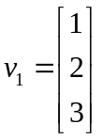, 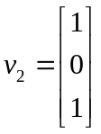, and 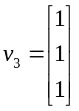.

Write 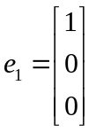 as a linear combination of ,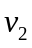, and 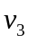 and use the linear combination to compute Ato find the first column of A.

